Steps to follow for communication between rasp and Arduino:

Step 1: Download Arduino IDE on the rasp using these steps.

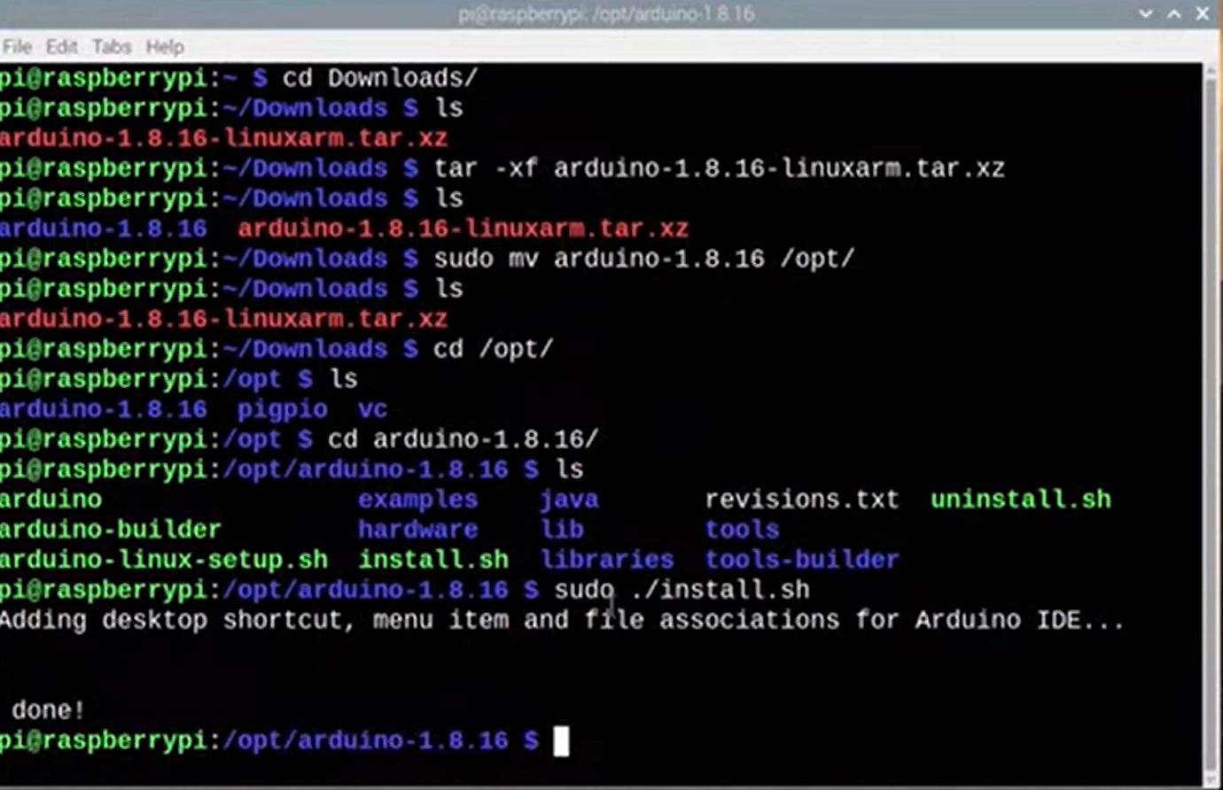

Step 2: Connect the rasp to the arduino. As shown below.

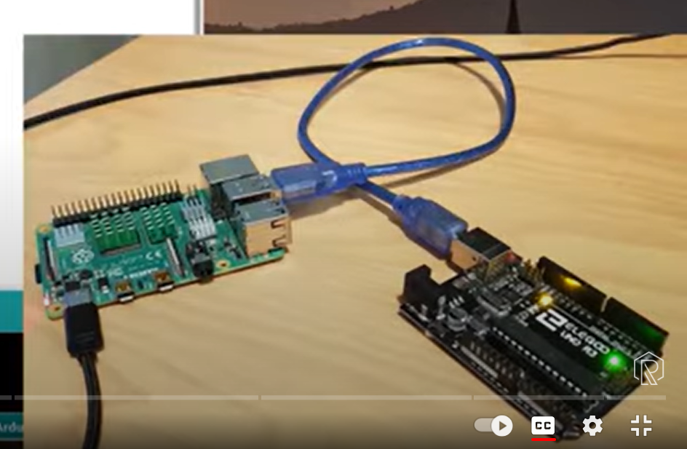

Step 3: Check what port is the arduino connected to by doing ls /dev/tty\* then unplug the arduino and run again and check what port is missing.

Step 4: Check the groups.

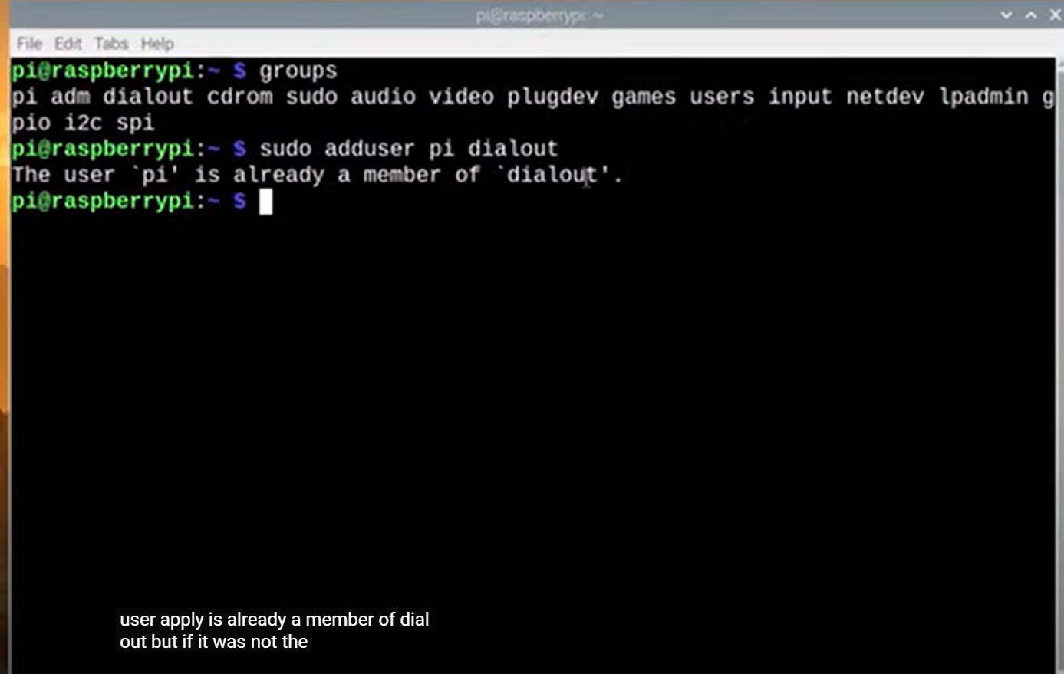

Step 5: Install the library Piserial by following these steps.

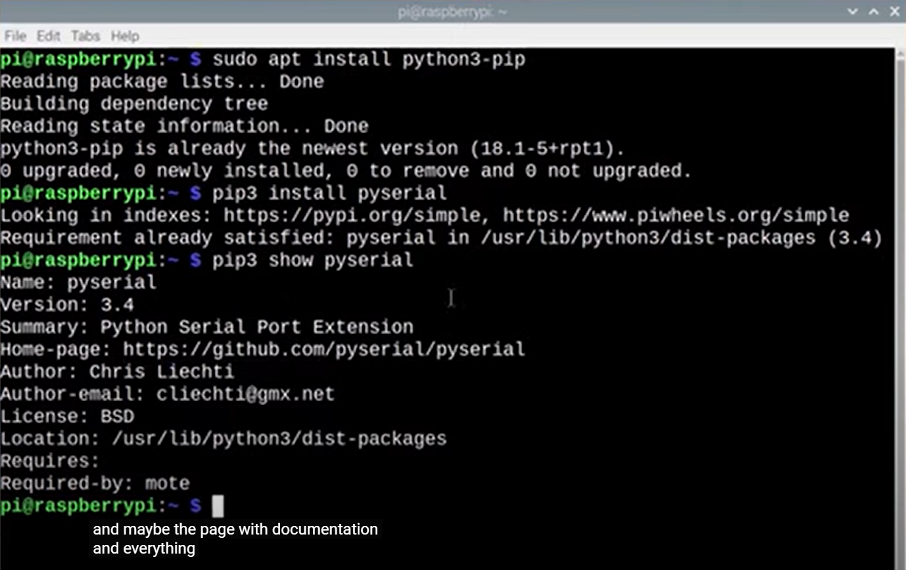

Step 6: Do this code below to test the communication.

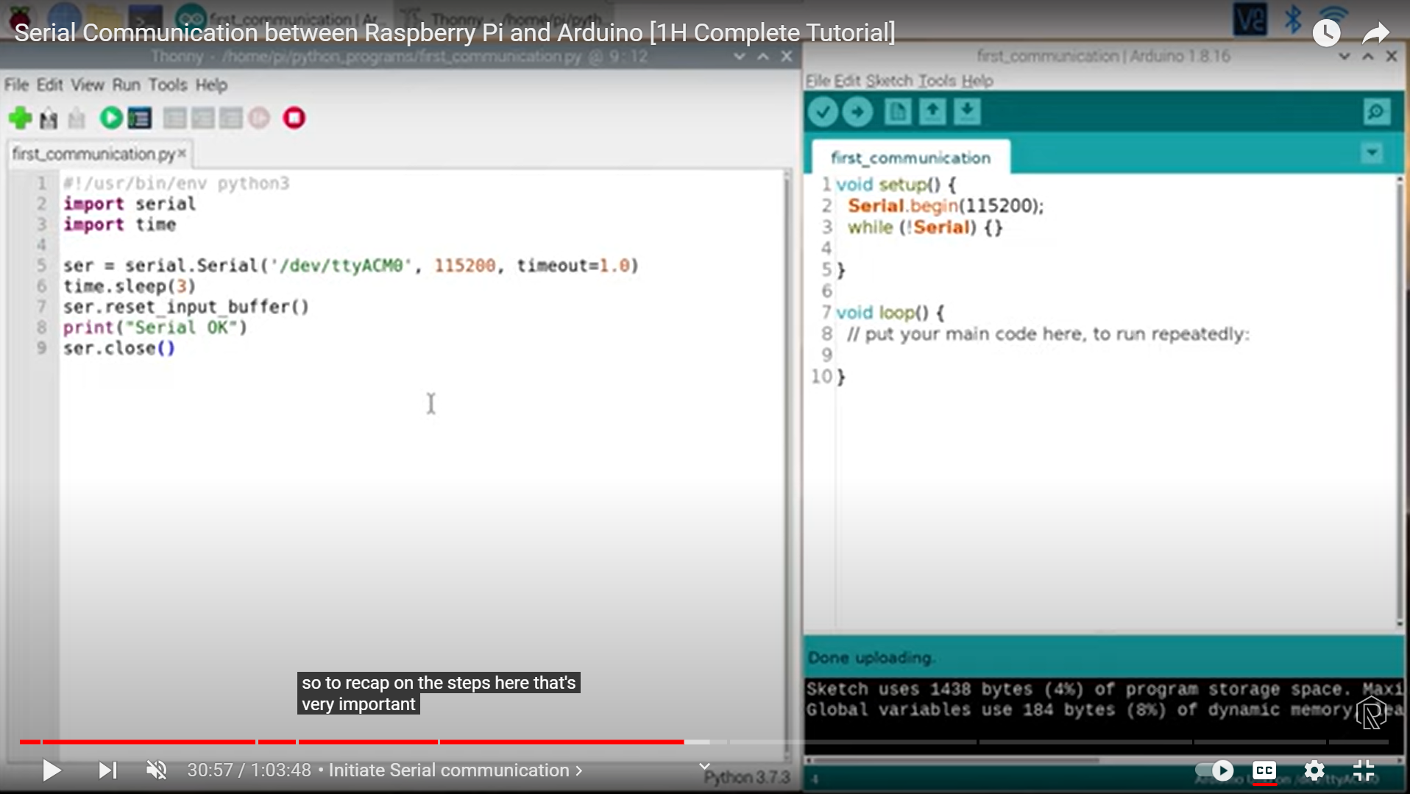

Step 7: Send data from Arduino to Pi.

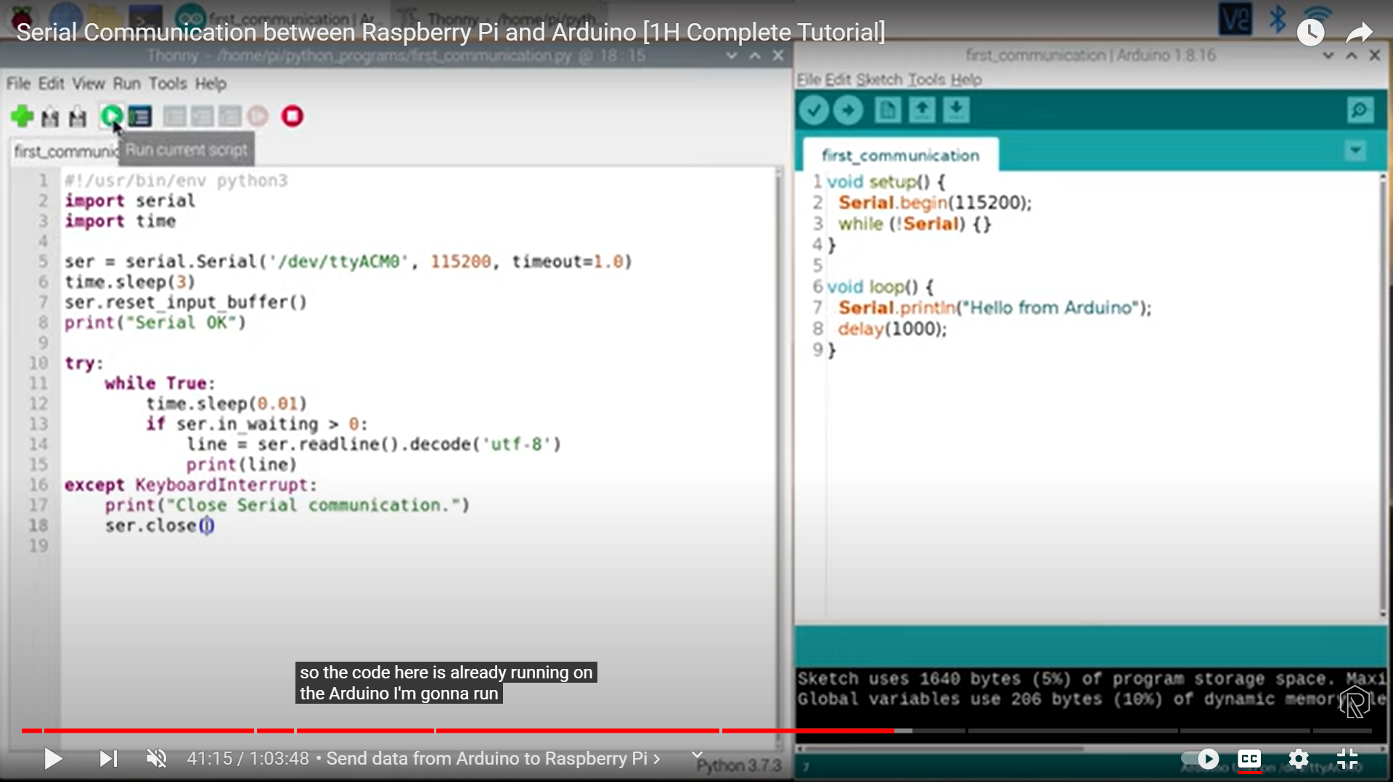

Step 8: Attention Have the same Serial begin. If no, the communication won’t work.

Step 9: Send data from pi to Arduino.

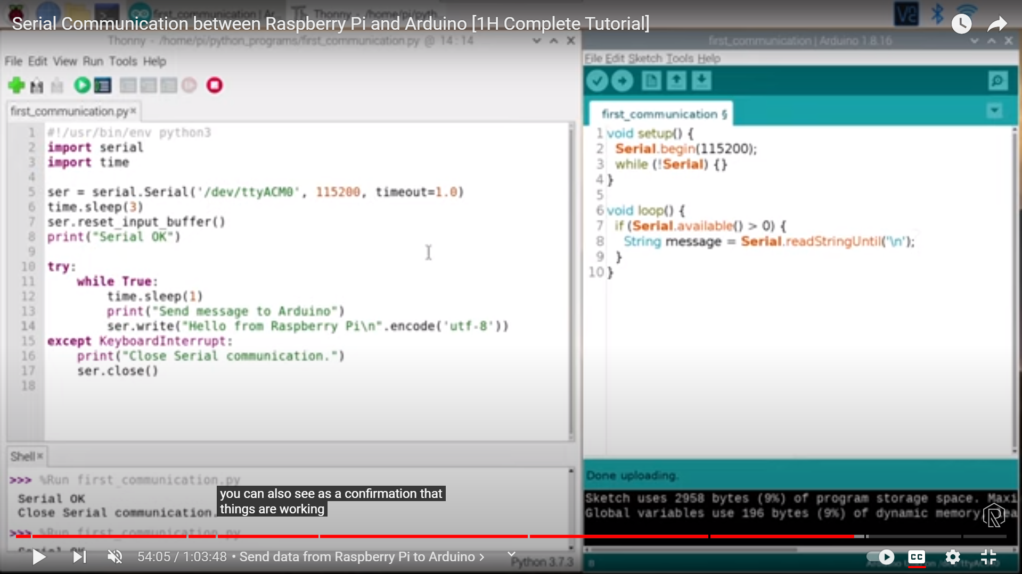

Step 10: Create Bidirectional communication.

